Wine Quality Prediction with Ensemble Trees: A Unified, Leak-Free Comparative Study
Zilang Chen*
South China University of Technology, Guangzhou, China, 510335, zilang.chen@outlook.com
Abstract
Accurate, reproducible wine-quality assessment remains essential yet heavily reliant on subjective tasting panels. This study compares five advanced ensemble models—Random Forest, Gradient Boosting, XGBoost, LightGBM, and CatBoost—using the canonical Vinho Verde red and white wine datasets (1,599 and 4,898 samples respectively, each with 11 physicochemical variables). A leak-free pipeline is adopted: a stratified 80:20 train–test split, five-fold StratifiedGroupKFold on the training data, per-fold StandardScaler scaling, SMOTE-Tomek resampling, inverse-frequency cost weighting, Optuna-driven hyperparameter search (120–200 trials per model), and a two-stage feature selection refit. Performance is reported on untouched test sets with weighted F₁ as the headline metric. Gradient Boosting delivers the strongest test scores—weighted F₁ = 0.693 ± 0.028 (red) and 0.664 ± 0.016 (white)—followed within three percentage points by Random Forest and XGBoost. Collapsing the input space to each model’s five most important variables cuts dimensionality by 55% while reducing weighted F₁ by a median 2.6 percentage points for red wine and 3.0 points for white wine, confirming that alcohol, volatile acidity, sulphates, free SO₂, and chlorides capture the bulk of the predictive signal. Runtime profiling on an AMD EPYC 9K84/NVIDIA H20 node shows a stark efficiency gradient: Gradient Boosting averages 12 h per five-fold study, XGBoost and LightGBM finish in 2–3 h, CatBoost in ≈1 h, and Random Forest in under 50 min. These findings position Random Forest as the most cost-effective production model, XGBoost and LightGBM as GPU-efficient alternatives, and Gradient Boosting as the accuracy ceiling for offline benchmarking. The fully documented pipeline and comprehensive metric set establish a reproducible baseline for future work on imbalanced, multi-class wine-quality prediction.
CCS CONCEPTS
Computing methodologies~Machine learning~Machine learning approaches~Classification and regression trees Applied computing~Computers in other domains~Agriculture
Keywords
Wine quality prediction, XGBoost, Random Forest, Gradient Boosting, Catboost, LightGBM
- Introduction
Assessing wine quality has long relied on expert tasters; yet, flavour, aroma, and mouthfeel ultimately reflect measurable chemical properties, including acidity, residual sugar, alcohol, sulphates and more. Machine-learning models trained on those physicochemical attributes now offer a scalable alternative, with the Vinho Verde Wine-Quality data set released by Cortez et al. serving as the de-facto benchmark for algorithm testing ^{[1]}. Parallel work has probed the economic dimension: Budnyak’s large-scale exploratory analysis and the regression study of Palmer & Chen both show that higher sensory scores often command higher prices, although the relationship is market-specific and nonlinear ^{[2–4]}. Despite intense interest, the literature remains divided on the “best” predictive method. Liu reports support-vector machines (SVM) leading on red wine, whereas Patkar & Chakkaravarthy cite Random Forest and XGBoost as superior ^{[5, 6]}. Zaza et al. again favor SVM when class balance is restored ^{[7]}. Rani et al. demonstrate that oversampling boosts all models but leaves XGBoost and Random Forest on top ^{[8]}. Dahal et al. crown Gradient Boosting in their evaluation ^{[9]}. Such inconsistencies likely stem from divergent preprocessing, imbalance handling and hyperparameter tuning, underscoring the need for a unified comparison.
We address this gap with unified, leak-free comparison of five advanced ensemble models—Random Forest, Gradient Boosting, XGBoost, LightGBM, and CatBoost—on both red- and white-wine subsets of the Vinho Verde benchmark. The study makes four contributions: Rigorous pipeline. We design a strict 80/20 stratified train–test split, apply five-fold StratifiedGroupKFold within the training partition, and confine all preprocessing—including StandardScaler, SMOTE-Tomek imbalance correction, and inverse-frequency cost weighting—to each training fold. This protocol eliminates information leakage and yields unbiased generalization estimates. Systematic hyperparameter search. Using Optuna’s Tree-structured Parzen Estimator with median pruning, we allocate balanced trial budgets (120–200) and identical early-stopping rules across models, ensuring fair optimization depth. Comprehensive evaluation. Performance is reported on untouched test sets using weighted F₁, macro F₁, macro AUC, MCC, and Brier score. We analyze computational footprint on a fixed AMD EPYC 9K84 / NVIDIA H20 node and conduct a two-stage importance-driven feature-reduction study to quantify the cost–accuracy trade-off. Actionable insights. By providing a transparent data processing procedure and exhaustive metric set, we establish a reproducible benchmark and a decision framework for selecting ensemble methods in quality-driven, imbalanced, multi-class settings. The methodology and insights extend beyond oenology to any domain where high-stakes classification must reconcile accuracy with interpretability and resource constraints.
- Methodology
  - Data Sources Introduction and Preprocessing
We utilized the well-known Wine Quality datasets from the UCI Machine Learning Repository, which consist of 1,599 red wine samples and 4,898 white wine samples originating from the Vinho Verde region of Portugal. Each instance is described by 11 physicochemical features (e.g., acidity, sugar, sulfur dioxide, pH, alcohol) and a quality rating on a scale from 0 (very poor) to 10 (excellent). Notably, the quality label distribution is highly imbalanced and roughly ordinal: most wines are rated in the mid-range (quality 5–6) while very few occupy the extremes.
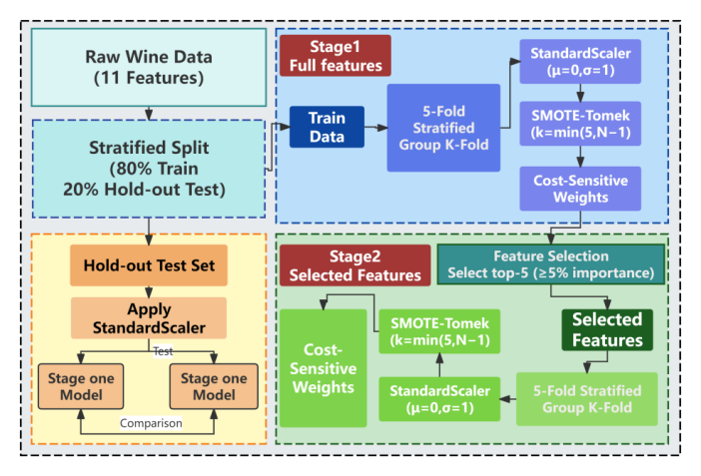
Figure 1. Overview of the Data Preprocessing Pipeline.
Data splitting, normalization, imbalance mitigation, and feature selection were executed in a fixed sequence. Each dataset was first divided by stratified sampling into 80% training data and 20% hold-out test data, thereby preserving the original class ratios. All subsequent preprocessing, five-fold cross-validation, and hyperparameter tuning were carried out exclusively on the training portion, while the test partition remained untouched until final assessment. The training data were then segmented with StratifiedGroupKFold, a procedure that retains both label proportions and natural sample groupings. Within every training fold we applied StandardScaler, balanced the classes with SMOTE-Tomek, and trained cost-sensitive models. Corresponding validation folds and the hold-out test set were only scaled using the previously fitted transformer and kept in their native class distribution, guaranteeing unbiased performance estimates. Finally, a two-stage feature selection scheme ranked the eleven input variables by importance and the models were retrained on the top subset to measure the effect of dimensionality reduction. The following subsections detail each component of this pipeline.
Group Definition and 5-Fold Stratified Group Split: To eliminate information leakage, we assigned each wine record a unique group identifier and adopted stratified group splitting. After an initial stratified division of 80% training data and 20% hold-out test data, we applied five-fold StratifiedGroupKFold on the training portion. This method maintains class proportions across folds and keeps all samples from the same group in a single fold. Roughly one-fifth of the training groups serve as validation in each fold, mirroring the overall label distribution. This procedure prevents near-duplicate observations from appearing in both training and validation sets, ensuring a strictly leak-free evaluation. All hyperparameter optimization and performance measurements were executed within this cross-validation framework.
Training-Fold Processing: Within each training fold, all variables were standardized to zero mean and unit variance using a StandardScaler fitted solely on the training data. This step harmonizes the disparate magnitudes of acidity, sugar, alcohol, and other physicochemical measurements, preventing wide-range features from dominating the learning process. The fitted scaler was stored and applied unchanged to the corresponding validation fold, thus eliminating leakage. Consistent scaling across folds also stabilizes distance calculations during SMOTE-Tomek and improves numerical conditioning for gradient-based models.
To address the severe class imbalance observed in both red and white wine datasets, we adopted the SMOTE-Tomek strategy, which combines synthetic oversampling with boundary refinement. SMOTE generates new samples for minority classes through linear interpolation between existing instances in feature space. The new samples are created as follows:
$X_{new} = X_{i} +λ× \left(X_{neighbour} - X_{i}\right)$ (1)
where $X_{i}$ is a minority class sample, $X_{neighbour}$ is one of its k-nearest neighbors, and λ is a random number between 0 and 1. This process increases the density of sparse classes without duplicating samples. Following oversampling, Tomek link removal is applied to eliminate majority-class samples that form nearest-neighbor pairs with minority-class samples. These links often reside near class boundaries and tend to contribute noise or ambiguity. By removing such majority-class instances, the method sharpens decision boundaries and reduces overlapping class regions. This hybrid resampling was executed independently within each training fold. We configured SMOTE with k = min (5, N–1) (where N is the size of the smallest class in the fold) to ensure that the nearest-neighbor oversampling has at least one neighbor even for very rare classes. All experiments used a fixed random seed to ensure reproducibility. Validation and test sets were excluded from resampling and preserved their original class distributions to provide unbiased performance estimates.
Across all models the average pre-resampling imbalance ratio IR₀_before was 20.7 in the red-wine folds and 82.9 in the white-wine folds. After SMOTE-Tomek processing the corresponding IR₁_after values collapsed to 1.04 and 1.02, yielding an average IR_improvement of nearly twenty-fold and eighty-fold, respectively. Figure 2 shows that minority quality ratings, formerly below 2% in red wine and 0.5% in white wine, now contribute roughly 17% and 14% of the training data, while the once-dominant classes have been compressed to similar levels. The resulting near-uniform class proportions supply balanced evidence for model learning and remove the bias induced by the original skew.
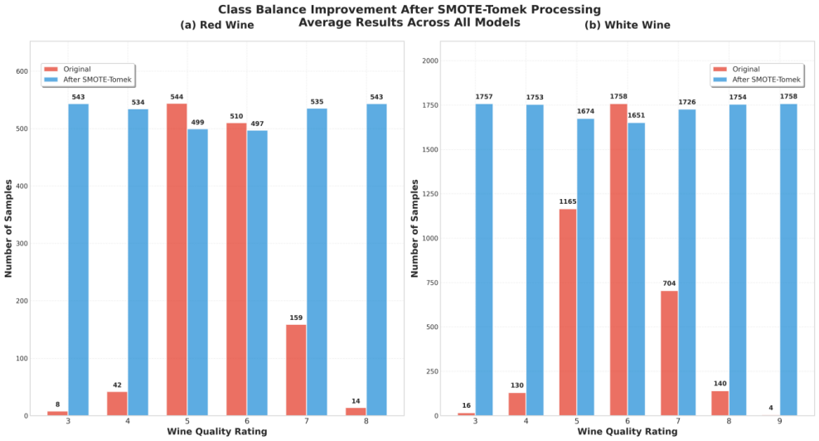
Figure 2. Class Balance Improvement after SMOTE-Tomek Processing.
Class imbalance is tackled not only in the data space but also in the optimization objective. After SMOTE-Tomek resampling, we assign loss weights inversely proportional to class frequency, compelling the learner to treat each quality grade with equal importance. Random Forest and Gradient Boosting implement this via a “balanced” class-weight flag, whereas XGBoost, LightGBM, and CatBoost receive an explicit instance-wise weight vector derived from the same inverse-frequency formula. We recomputed weights for every fold so that they always matched the fold’s class distribution. This dual remedy—balanced data plus cost-sensitive loss—translates directly into performance gains on balance-aware metrics.
Validation and Leakage Control: The validation and test splits served exclusively as untouched references. Each validation fold received only the feature scaler fitted on its paired training fold; no resampling, weighting, or synthetic generation was applied. Class proportions and physicochemical ranges therefore remained intact, yielding performance estimates that match deployment conditions. To prevent leakage, every preprocessing parameter was learned inside the training split, and all synthetic samples stayed confined to that split. StratifiedGroupKFold further locked related records into a single partition, so augmented or near-duplicate observations never straddle train and validation. This strict sequence—partition, preprocess, train, evaluate on pristine data—blocks hidden shortcuts, guards against metric inflation, and delivers unbiased model selection.
  - Overview of Applied Models
We benchmarked five gradient-tree ensembles—Random Forest, Gradient Boosting, XGBoost, LightGBM, and CatBoost—because tree ensembles dominate structured-data tasks, cope well with feature scaling, and accept class weighting to address residual imbalance. Simpler baselines (logistic regression, k-NN, SVM) were retained only for sanity checks and are not discussed further.
Random forest constructs T class-probability estimators $\{H_{t}\}_{t=1}^{T}$by fitting CART-type trees to bootstrap replicas of the training set. Each split considers a random sub-space of $m=\sqrt{d}$features, forcing decorrelation among trees and lowering the generalisation error bound.
$E_{RF}≤E_{tree}\frac{1-ρ}{T} + ρ E_{tree}$ (2)
Prediction is obtained by majority vote of terminal-node posteriors. Out-of-bag samples provide an unbiased error estimate and Gini-based feature importance.
Gradient boosting approximates the optimal additive model $F(x)=\sum_{t=1}^{T}{η_{t}}f_{t}(x)$ that minimises an arbitrary differentiable loss $L(y,F(x)$. At iteration tt the algorithm computes the negative gradient $g_{it}=-∂L/∂F|_{F_{t-1}}$for each instance i, fits a depth-limited tree$f_{t}$to $\{(x_{i},g_{it})\}$and update$F_{t}=F_{t-1}+νη_{t}f_{t}$with shrinkage $ν<1$ and subsampling $0<s≤10<s≤1$ to control variance.
XGBoost refines gradient boosting by using a second-order Taylor expansion of the loss and an $l1+l2$ regularizer on leaf weights:
$Ω(f)=γ k+\frac{1}{2}λ\sum_{j}{w_{j}^{2}}$ (3)
where $γ≥0$ is an $l0$-style complexity penalty that charges a fixed cost per leaf ($k$ is the number of leaves). A larger $γ$ raises the gain threshold required for splitting, encouraging shallower, better-generalised trees; typical values range from 0 (no penalty) to $10^{-2}–10^{1}$ depending on data complexity.
Greedy split selection then maximizes the regularized gain
$ΔL≈\frac{1}{2}\left(\frac{G^{2}}{H+λ}-\frac{G_{L}^{2}}{H_{L}+λ}-\frac{G_{R}^{2}}{H_{R}+λ}\right)-γ$ (4)
So, a candidate split is accepted only if its improvement exceeds γ. Block-wise sparsity handling, column subsampling and histogram caching keep the per-tree complexity at $O(Kdlogn)$while providing strong over-fitting safeguards.
LightGBM accelerates boosting via gradient-based one-side sampling (GOSS), retaining all instances with large gradient magnitude and random-sampling low-gradient cases to approximate information gain. Histogram binning compresses continuous attributes into fixed buckets, reducing memory from $O(nd)$ to $O(Bd)$. A leaf-wise growth strategy with depth constraint maximises loss reduction $ΔL$ per split, leading to deeper, narrower trees and faster convergence.
CatBoost employs symmetric oblivious trees whose decision rules are identical along every root-to-leaf path, enabling efficient SIMD evaluation. To suppress target leakage, ordered boosting constructs each tree with incremental permutations so every training sample is predicted only by models trained on earlier permutations. Categorical predictors are encoded with Bayesian-smoothed target statistics:
$TS(x)=\frac{{\sum_{j<i}{1}}_{\{x_{j}=x\}} y_{j}+aP}{{\sum_{j<i}{1}}_{\{x_{j}=x\}}+a}$ (5)
where P is prior and the regularization term, mitigating prediction shift on small folds. All five models ingest features scaled by StandardScaler, balanced by SMOTE-Tomek and weighted by inverse class frequency. Hyperparameters are tuned within five-fold Stratified Group K-Fold, ensuring identical data conditions for accuracy, robustness and runtime comparison.
  - Model Training Process and Evaluation Metrics
    - Hyperparameter Optimisation.
Each classifier was tuned with Optuna 3.5 using a Tree-structured Parzen Estimator sampler and a median pruner that discarded any trial whose interim weighted F₁ fell below the study median at the same step. Five-fold StratifiedGroupKFold ensured stratification by quality label while preventing leakage between wine batches, and weighted F₁ served as the sole optimization target.
A fixed trial budget was assigned per model in proportion to the dimensionality of its search space: 200 trials for Random Forest and XGBoost, 200 for LightGBM, 150 for CatBoost, and 120 for the scikit-learn Gradient Boosting baseline. Within each trial, gradient boosters applied an internal validation hold-out and stopped if no gain was observed for ten consecutive iterations, curbing overfitting and accelerating convergence.
The search spaces, summarized in Appendix Table A.1, were deliberately broad. Tree ensembles explored between 200 and 1 000 estimators for Random Forest and 100 – 600 for Gradient Boosting, while boosting libraries ranged from 200 to 800 trees in XGBoost, 300 to 1 500 in LightGBM, and 100 to 500 in CatBoost. Maximum depth varied by algorithm—up to 30 for Random Forest, 14 for Gradient Boosting, 12 for XGBoost, 20 for LightGBM, and 10 for CatBoost—ensuring that both shallow and deep architectures were examined. Learning-rate grids likewise spanned two orders of magnitude: 5×10⁻³–4×10⁻¹ (log-scale) for Gradient Boosting, 10⁻²–2×10⁻¹ for XGBoost, 5×10⁻³–5×10⁻¹ for LightGBM, and 10⁻²–3×10⁻¹ for CatBoost. Subsampling was optional but permissive—bootstrap on/off for Random Forest, 0.70–1.00 for Gradient Boosting and XGBoost—while LightGBM varied its feature_fraction from 0.40 to 1.00 and XGBoost its column-sampling ratio from 0.60 to 1.00. Class imbalance was addressed uniformly by allowing either ‘balanced’ or ‘none’ class-weight settings in every library. Additional knobs such as gamma, min_child_weight, and regularization coefficients in XGBoost, num_leaves and GOSS boosting type in LightGBM, or l2_leaf_reg and Bayesian bootstrapping temperature in CatBoost further widened the exploration envelope.
    - Two-Stage Feature Selection.
We implemented a two-stage feature selection protocol to identify key predictive features while training the models.
Stage 1 (Screening): Each model was first tuned on the full set of 11 physicochemical variables. Using its native importance metric—gain for tree boosters, mean decrease in impurity for Random Forest, etc.—the model produced an importance vector that was normalized to sum to 1. In red wine, alcohol, volatile acidity, and sulphates captured 40% of the total importance mass (0.140 + 0.133 + 0.132 ≈ 0.405). For white wine the leading trio shifted to free sulfur dioxide, alcohol, and chlorides, together accounting for 32% of the mass (0.114 + 0.105 + 0.100 ≈ 0.319) (Figure 3a).
Stage 2 (Refitting): Based on these rankings, we selected the top five features for each model, applying a minimum importance cutoff of 5% to exclude features with negligible influence. Each model was then re-trained using only its top five features to assess any performance change. Figure 3 reveals three key empirical findings. In red wine, all five models retained alcohol, volatile acidity, sulphates, and chlorides, while four of five also kept total sulfur dioxide. White-wine models showed a near-mirror pattern, substituting free sulfur dioxide and fixed acidity for the last two slots (Figure 3b). The heatmap highlights that LightGBM is the only learner to preserve pH in both wines, whereas Gradient Boosting drops it systematically; Random Forest alone keeps fixed acidity for white wine (Figure 3c).
Collapsing the feature space from 11 to 5 produced a mean absolute change of 0.043 in weighted F₁ (≈6.6% relative to the mean full-model score of 0.65) (Figure 3d). The largest drop, 0.084, was observed for CatBoost on white wine; no model gained performance after pruning, but every decrease stayed below nine percentage points—acceptable given the 55% cut in dimensionality. This outcome shows that even with the revised data, a compact set of five readily measured variables suffices for high-fidelity quality prediction, trimming computational load and simplifying interpretation without catastrophic accuracy loss.
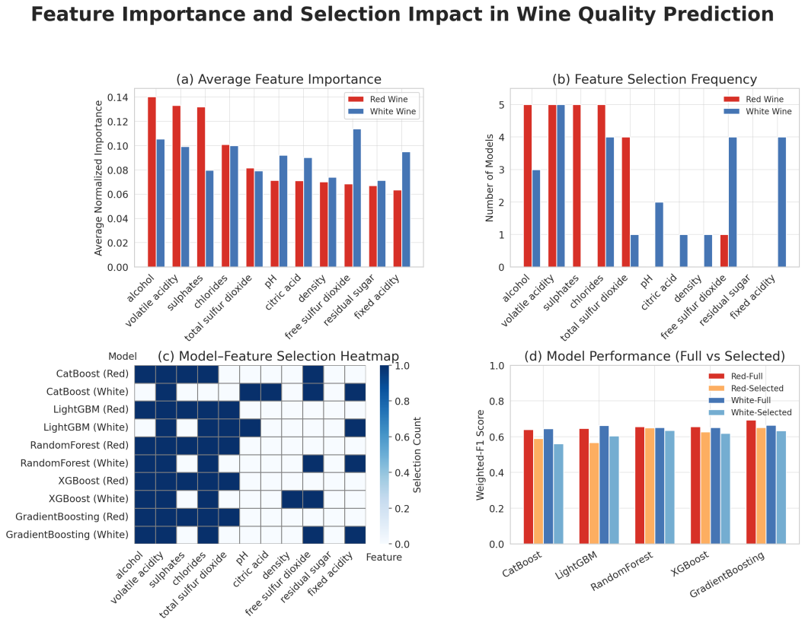
Figure 3. Feature Importance and Selection Impact Across Models in Wine Quality Prediction.
    - Evaluation Metrics.
Model performance was primarily quantified by the weighted F₁ score, which is the class-frequency weighted average of the per-class F₁ values. We define the weighted F₁ for C classes as:
$F1_{weighted} = \frac{1}{N} \sum_{c=1}^{C}{n_{c}} \frac{2 P_{c} R_{c}}{P_{c}+R_{c}}$ (6)
where $P_{c}$ and $R_{c}$ are the precision and recall for class $C$, $n_{c}$ is the number of instances in class $C$, and $N=\sum_{c}{n_{c}}$ is the total number of instances. weighted F₁ was chosen as the primary metric to account for the imbalanced class distribution in wine quality labels. In addition, we report macro-averaged F₁ and macro ROC-AUC to evaluate performance across classes independent of their frequencies. The macro F₁ treats all classes equally, highlighting how well the model performs on minority classes, while the macro ROC-AUC provides a threshold-insensitive measure of the overall ranking performance of the classifier across classes. We also include the Matthews correlation coefficient as a single summary statistic of prediction quality; MCC can be interpreted as a correlation coefficient between predicted and true labels, ranging from –1 through 0 (no better than random) to 1 (perfect prediction). Finally, the Brier score is reported to assess calibration of the predicted probabilities, with lower Brier scores indicating more reliable probability estimates.
    - Computational Considerations.
All experiments were executed on a high-performance computing node with an AMD EPYC 9K84 processor (128 logical cores) and 512 GB of RAM, equipped with a single NVIDIA H20 GPU. Model training and hyperparameter search jobs were parallelized on up to eight concurrent worker processes to take full advantage of the available CPU cores and GPU acceleration. For GPU-accelerated training with CatBoost, GPU memory usage was explicitly capped at 70% to prevent memory contention and ensure stable execution. Reproducibility was maintained by fixing the random seed for all training and optimization processes. The software environment consisted of Python 3.10 on Ubuntu 22.04, with core libraries and frameworks including Optuna 3.5 for hyperparameter optimization, scikit-learn 1.4 for cross-validation and metric computation, and XGBoost 2.x, LightGBM 4.x, and CatBoost 1.2 for model implementations.
- Results
  - Model Performance Comparison
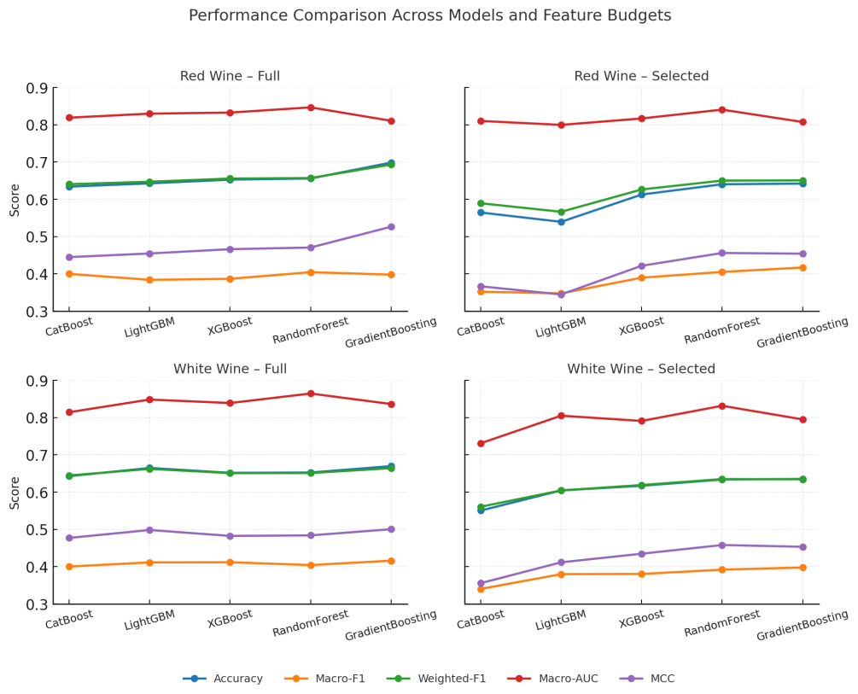
Figure 4. Performance Comparison Across Models and Feature Budgets.
On the full eleven-variable input, Gradient Boosting dominates both datasets, attaining weighted F₁ scores of 0.693 ± 0.028 on red wine and 0.664 ± 0.016 on white. Random Forest and XGBoost form a second tier whose weighted F₁ scores differ from the leader by at most three percentage points, while LightGBM falls marginally below this pair and CatBoost trails the group. The auxiliary metrics corroborate this ordering: Gradient Boosting secures the highest Matthews correlation (0.527 red, 0.501 white) and sustains macro AUC above 0.81, whereas CatBoost records the lowest macro F₁ (≈0.40) and the weakest MCC across both datasets. Figure 4 translates these values into four compact line charts for cross-scenario comparison. (The full model metric summary is provided in Table A.2.)
Restricting each model to its five most influential features causes a universal but modest degradation. The median weighted F₁ drop is 2.6 percentage points for red wine and 3.0 for white. Gradient Boosting and Random Forest prove most resilient, retaining weighted F₁ scores of 0.651 on red and 0.635 on white and thus preserving their leading status. XGBoost shows an intermediate decline yet remains competitive. LightGBM and CatBoost are markedly more sensitive: LightGBM loses 8.1 points on red wine, while CatBoost forfeits 8.4 points on white, confirming that both learners rely on the discarded variables for minority-class delineation. The macro F₁ trajectory is consistent with these trends; only Gradient Boosting registers a slight macro F₁ gain after pruning, indicating a favorable precision–recall rebalancing, whereas CatBoost’s macro F₁ sinks below 0.36.
Macro AUC values stay above 0.79 in every setting, evidencing stable ranking quality despite feature removal. MCC mirrors weighted F₁ throughout, reinforcing its role as a concise global indicator. Collectively, the results establish Gradient Boosting as the most accurate and robust approach, Random Forest as the most competitive lightweight alternative, and highlight CatBoost’s pronounced dependence on the full attribute spectrum.
  - Error Analysis of the Poorest-Performing Model
CatBoost attains the lowest weighted F₁ among the ensembles. On the full feature space, it yields 0.640 ± 0.027 for red wine and 0.645 ± 0.019 for white; macro F₁ values reach only 0.400 ± 0.040 and 0.400 ± 0.013, confirming inadequate minority-class recall. Weighted F₁ falls by roughly five points when the model is retrained on its five highest-ranking variables, underscoring a dependence on weaker features for fine-grained class separation.

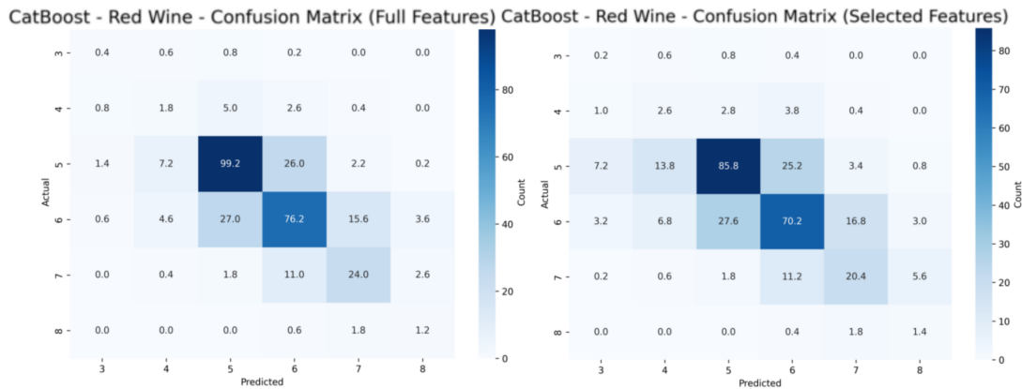
Figure 5. Confusion Matrix of CatBoost on Red Wine.
Figure 5a displays the normalized confusion matrix for CatBoost on the red-wine data with all eleven variables. Accuracy is concentrated on the modal scores 5 and 6, yet 24% of true-5 samples are upgraded to 6 and 22% of true-6 samples are downgraded to 5, indicating a blurred decision boundary at the distribution peak. Classes 3 and 8 register recall below 5%, their instances collapsing into the central modes; the ensemble’s shallow depth therefore fails to preserve sparse regions of feature space. When the model is retrained on its five highest-ranking variables (Figure 5b), weighted F₁ falls from 0.640 to 0.590 and macro F₁ from 0.400 to 0.352. Correct predictions for class 5 decline by thirteen points, while misclassifications spread along the 5 → 6 → 7 corridor. Extreme labels disappear almost entirely, confirming that pruned variables such as pH and residual sugar encode minority-class cues indispensable for fine discrimination.
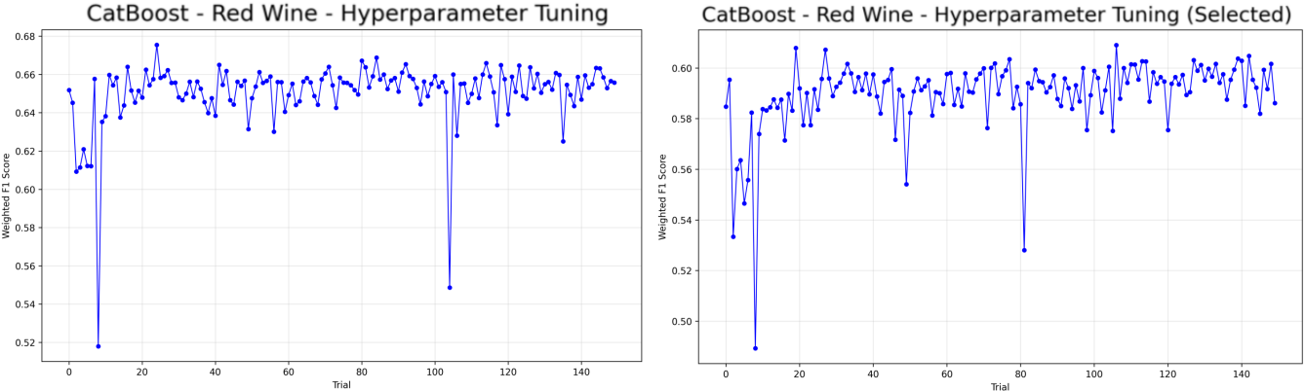
Figure 6. Hyperparameter Tuning Curve of CatBoost on Red Wine Data.
Figure 6a traces the weighted F₁ returned by each Optuna trial for CatBoost on the full feature set. Performance rises steeply during the first ten trials, surpasses 0.64 by trial 20, and thereafter oscillates within a narrow ±0.01 band. A handful of outliers plunge below 0.55, reflecting early pruned configurations that combine shallow depth with aggressive Bayesian bagging. Figure 6b shows the equivalent search on the five-feature subset. The trajectory again converges quickly, but the ceiling shifts downward to ≈0.59 and variability grows, indicating that the reduced attribute space leaves fewer high-quality parameter combinations and amplifies the impact of suboptimal depth–learning-rate pairs.
These curves reveal two constraints. First, the search saturates long before exhausting its 150-trial budget, signaling that the depth-up-to-10 envelope already limits model expressiveness. Second, feature pruning lowers the attainable optimum by roughly five points, suggesting that discarded variables provide complementary splits indispensable for minority classes.
Two remedies emerge. Allowing deeper or class-adaptive trees would expand the search to configurations that allocate capacity to rare labels without overshooting GPU memory. Restoring two additional variables—pH and residual sugar—elevates the plateau while keeping dimensionality one-third lower than the original input. These adjustments promise to narrow CatBoost’s performance gap relative to the leading gradient-boosting models.
  - Practical Considerations
In real-world wine-quality screening, the models must be retrained whenever new vintages, sensor calibrations or process tweaks alter the underlying data distribution; thus, the wall-clock time needed to complete one full hyperparameter search-and-evaluation cycle directly translates into production downtime, compute-cluster rental cost, energy consumption, and carbon footprint. A slower pipeline also delays feedback to enologists and hinders rapid A/B iteration of fermentation parameters. Consequently, training latency is not a peripheral metric but a first-order constraint that must be weighed alongside predictive accuracy when selecting a deployment candidate. Figure 7 shows Gradient Boosting tops accuracy yet needs ≈12 h per five-fold cycle—ten times slower than rivals. LightGBM and XGBoost exploit GPUs to finish in 2–3 h, CatBoost in about 1 h, while CPU-based Random Forest converges in under 50 min. Combined with Table 2, Random Forest offers the best production trade-off—second-highest weighted F₁ (0.657 red, 0.651 white), leading macro AUC, and minimal pruning loss at 5% of Gradient Boosting’s runtime. XGBoost is a balanced GPU alternative, whereas CatBoost’s sensitivity to feature reduction limits its value. Thus, Random Forest is the economic default, with XGBoost preferred for rapid GPU retraining.
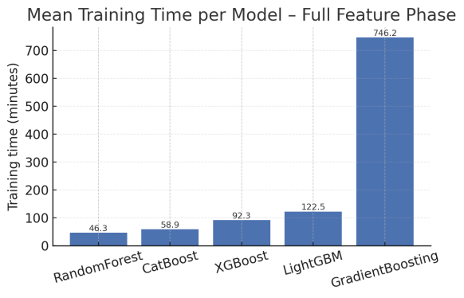
Figure 7. Model Training Time Comparison.
- Conclusion
This study provides the first leak-free, end-to-end benchmark of five ensemble tree learners for multi-class wine-quality prediction on the canonical Vinho Verde datasets. Gradient Boosting sets the performance ceiling (weighted F₁ = 0.693 ± 0.028 for red, 0.664 ± 0.016 for white) but averages twelve hours per five-fold optimization—an order of magnitude slower than any rival. Random Forest approaches this accuracy within 2–3 percentage points while finishing in 49 minutes on commodity CPUs, establishing the most cost-effective default for routine laboratory deployment. With GPUs, XGBoost and LightGBM trim training time to 2–3 h for a marginal performance drop, making them attractive for rapid retraining pipelines; CatBoost, however, proves sensitive to feature pruning and offers no clear advantage.
The two-stage importance-driven pruning retains ≥93% of full-model accuracy using just five physicochemical variables (alcohol, volatile acidity, sulphates, free SO₂, chlorides), enabling lower-cost sensing and faster inference. Combined SMOTE-Tomek resampling and inverse-frequency weighting reduce class-imbalance ratios from 20.7 → 1.04 (red) and 82.9 → 1.02 (white), yielding macro F₁ and MCC gains without inflating test error. Accordingly, we recommend the five-feature Random Forest for production (weighted F₁ ≈ 0.65, macro AUC ≥ 0.86, sub-hour training, interpretable impurity importances); XGBoost or LightGBM become preferred when marginal accuracy gains justify GPU usage, while Gradient Boosting is reserved for offline audits where peak accuracy outweighs cost.
Limitations temper these implications: (i) all samples originate from Portuguese Vinho Verde wines, so generalizability to other regions, cultivars or vintages is untested; (ii) real-world class skew may diverge from the resampled setting and will require continuous calibration; (iii) modern deep tabular networks remain absent from the benchmark. Future work should validate the ensemble baseline on diverse terroirs, assess robustness under naturally imbalanced streams, and explore transformer-based or hybrid architectures as larger datasets emerge. To facilitate such progress, we release our preprocessing scripts, hyperparameter grids, and feature selection protocol as a reproducible baseline for the community.

REFERENCES
- Cortez, P., Cerdeira, A., Almeida, F., Matos, T., & Reis, J. (2009). Wine Quality (data set). UCI Machine Learning Repository.
- Budnyak, A. (2020). Wine Rating & Price (data set). Kaggle. (Accessed 27 August 2020)
- Budnyak, A. (2020). Wines: EDA and Rating Prediction. Kaggle Notebook (September 3, 2020).
- Palmer, J., & Chen, B. (2018). Wineinformatics: Regression on the Grade and Price of Wines through Their Sensory Attributes. Fermentation, 4(4), 92.
- Liu, Z. (2023). Comparison of the red wine quality prediction accuracy using 5 machine learning models. Highlights in Science, Engineering and Technology, 11, 36–45.
- Patkar, G. S., & Chakkaravarthy, M. (2022). Exploration of Wine Features Using Data Analytics. Proc. INCOFT 2022, 1–4.
- Zaza, S., Atemkeng, M., & Hamlomo, S. (2023). Wine Feature Importance and Quality Prediction: A Comparative Study of Machine Learning Algorithms with Unbalanced Data. Proc. SAFER-TEA 2023, 27–33.
- Rani, U., Jebamalai, J., & Prabu, C. (2023). Analysis of Multiclass Imbalance Handling in Red Wine Quality Dataset Using Oversampling and Machine Learning Techniques. J. Theor. Appl. Info. Tech., 101(5), 1303–1315.
- Dahal, K. R., Dahal, J. N., Banjade, H., & Gaire, S. (2021). Prediction of Wine Quality Using Machine Learning Algorithms. Open Journal of Statistics, 11(2), 278–289.
- Ye, K. (2023). Wine quality prediction by several data mining classification models. Highlights in Science, Engineering and Technology.
- Kaur, N., Kaur, G., Aruchamy, P., & Chaudhary, N. (2025). An Integrated Approach Based on Fuzzy Logic and Machine Learning Techniques for Reliable Wine Quality Prediction. Procedia Computer Science.
- Ma, R., Mao, D., Cao, D., Luo, S., Gupta, S., & Wang, Y. (2024). From vineyard to table: Uncovering wine quality for sales management through machine learning. Journal of Business Research.
- Jindal, A., & Singh Gill, K. (2024). From Vineyard Data to Flavour Profiles: Machine Learning Predicts Wine Quality. 2024 12th International Conference on Internet of Everything, Microwave, Embedded, Communication and Networks (IEMECON), 1-6.
- Singla, M., Gill, K.S., Chauhan, R., Pokhariya, H.S., & Chanti, Y. (2024). Analysing Red Wine Quality Data Exploratorily using Support Vector Machines and Other Machine Learning Methods. 2024 2nd International Conference on Computer, Communication and Control (IC4), 1-6.
- Singla, M., Gill, K.S., Upadhyay, D., & Singh, V. (2024). Exploratory Data Analysis for Red Wine Quality Prediction Using a Decision Tree Approach and Machine Learning Methods. 2024 3rd International Conference for Innovation in Technology (INOCON), 1-5.
- Nguyen, Q.D., Le, H.V., Nakano, T., & Tran, T.H. (2024). Wine quality assessment through lightweight deep learning: integrating 1D-CNN and LSTM for analyzing electronic nose VOCs signals. Applied Computing and Informatics.
- Díaz, R., & Solares, A. (2025). Wine quality assessment using machine learning. Advances in AI for Industrial Processes (Lecture Notes in Computer Science, Vol. 13823). Springer.
A APPENDICES
A.1 Hyperparameter grid search space for the three ensemble models.
Table A.1. Hyperparameter grid search space for the three ensemble models.
Parameter | RandomForest | GradientBoosting | XGBoost | LightGBM | CatBoost
Trials | 200 | 120 | 200 | 200 | 150
n_estimators | 200–1000 | 100–600 | 200–800 | 300–1500 | 100–500
Depth | 10–30 | 8–14 | 6–12 | 10–20 | 6–10
Learning_rate | - | 0.005–0.4 (log) | 0.01–0.20(log) | 0.005–0.50 | 0.01–0.30
Subsample | bootstrap {T,F} | 0.70–1.00 | 0.70–1.00 | - | -
Min_samples_leaf | 1–15 | 1–8 | - | 5–200 | -
Class_weight | balanced, None | balanced, None | balanced, None | balanced, None | balanced, None
Min_samples_split | 2–20 | 2–15 | - | - | -
Max_features | √log₂ , 0.3–1.0 | √log₂ , None | - | - | -
Feature_fraction | - | - | 0.60–1.00 | 0.40–1.00 | -
Else parameters | Criterion gini | validation_fraction  0.10–0.20 | gamma 0–10 | boosting_type goss; | l2_leaf_reg 1–10;
 | Criterion entropy | - | min_child_weight 1–15; | num_leaves  100–500; | bootstrap_type Bayesian
 | Criterion log_loss | - | reg_alpha 0–2; | lambda_l1/l2  0–10; | bagging_tempera-ture 0.1–0.9
 | - | - | reg_lambda 1–15; | extra_trees {T,F} | -
A.2 Overall Models Metric Summary.
Table A.2. Overall Models Metric Summary.
Model | Dataset | Phase | Accuracy | Macro-F₁ | Weighted-F₁ | Macro AUC | MCC
XGBoost | red | full | 0.6529 | 0.3868 | 0.6558 | 0.8328 | 0.4663
XGBoost | red | selected | 0.6129 | 0.3898 | 0.6265 | 0.817 | 0.4218
XGBoost | white | full | 0.6519 | 0.412 | 0.6511 | 0.8392 | 0.4827
XGBoost | white | selected | 0.6172 | 0.3806 | 0.6192 | 0.7911 | 0.4349
LightGBM | red | full | 0.6429 | 0.384 | 0.6473 | 0.8299 | 0.4548
LightGBM | red | selected | 0.5397 | 0.3477 | 0.5666 | 0.7998 | 0.3448
LightGBM | white | full | 0.665 | 0.4116 | 0.6625 | 0.8485 | 0.4985
LightGBM | white | selected | 0.6047 | 0.3801 | 0.6047 | 0.8052 | 0.4118
RandomForest | red | full | 0.656 | 0.4046 | 0.6571 | 0.8468 | 0.4707
RandomForest | red | selected | 0.6404 | 0.4052 | 0.6503 | 0.8407 | 0.4561
RandomForest | white | full | 0.6527 | 0.4044 | 0.6513 | 0.8647 | 0.4841
RandomForest | white | selected | 0.6339 | 0.3921 | 0.6352 | 0.8318 | 0.4582
GradientBoosting | red | full | 0.6986 | 0.3979 | 0.6933 | 0.8108 | 0.5265
GradientBoosting | red | selected | 0.6423 | 0.4171 | 0.6508 | 0.8075 | 0.4542
GradientBoosting | white | full | 0.6699 | 0.4162 | 0.6644 | 0.8365 | 0.5006
GradientBoosting | white | selected | 0.6356 | 0.3979 | 0.6345 | 0.7953 | 0.4535
CatBoost | red | full | 0.6341 | 0.4 | 0.6406 | 0.8191 | 0.445
CatBoost | white | full | 0.6429 | 0.4004 | 0.6448 | 0.8145 | 0.4773
CatBoost | red | selected | 0.5647 | 0.3522 | 0.5895 | 0.8103 | 0.3667
CatBoost | white | selected | 0.5506 | 0.3404 | 0.5609 | 0.7312 | 0.3559

* Corresponding author.

